Board of Directors
Stephanie Stibal, Chair
Tommy Van Lith, Vice Chair
Amanda Viebrock, Member
Zach Gormley, Member
Martin Wachtel, Member
Tabatha Mires, Secretary

WATERVILLE SCHOOL DISTRICT 200 East Birch Street ~ P.O. Box 490 ~ Waterville, WA 98858

Waterville Board Meeting
February 28, 2023
6:00 pm
Career Center

1. Call to order and flag salute
Presenter: Stephanie Stibal
2. Approve and make additions to Agenda
Presenter: Stephanie Stibal
3. Consent Agenda
Presenter: Stephanie Stibal
- Board Minutes
  - January Regular Meeting – January 25, 2023 6 pm
  - February Special Meeting – February 3, 2023 10 am
b. Accounts Payable
c. Payroll
d. Superintendent Report
e. High School Principal Report
f. Elementary Principal Report
g. Athletic Director Report
h. Resignation
h. Donations
Direct Relief Donation of Narcan Valued at $250.
i. Fund Raisers
j. Surplus Items
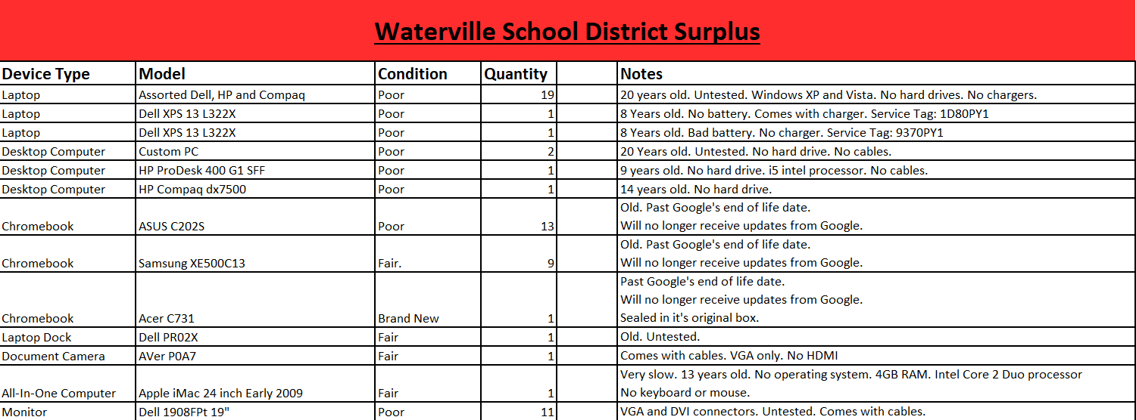
k. Correspondence
OSPI Administrative Review – Food Service Closure Correspondence
4. Public Comments
a. Written comments will only be accepted via regular mail to Waterville
School District, or email to gmullendore@waterville.wednet.edu.
Comments critical of personnel, students or volunteers will not be read
given privacy concerns. Instead, they will be referred to the
Superintendent for further inquiry and possible action.
5. Reports
a. Financial Report
Presenter: Sally Ryan
b. Superintendent Update
Presenter: Tabatha Mires
c. Legislative Report
Presenter: Marty Wachtel
6. New Business
a. 2023-2024 Staffing and Budget
Presenter: Tabatha Mires/Sally Ryan/ Jon Gasbar/Tayn Kendrick
b. Facilities and Clean Buildings Legislation https://www.commerce.wa.gov/growing-the-economy/energy/buildings/
Presenter: Tabatha Mires
c. Legislative Assembly WSSDA Resolution (Action)
Presenter: Martin Wachtel
d. Bilingual Program Approval (Action)
https://eds.ospi.k12.wa.us/iGrants/(S(a3ndou45mrixokbi4hfa0o45))/WebPages/GrantWriterPages/FormPagePrint.aspx?printable=true&PrintAll=true&Id=4028&Number=1&PNumber=1&HId=100288&PHId=-1&GM=0&FPID=3809
Presenter: Tabatha Mires / John Mullen
e. Social Media Legislation
Presenter: Tabatha Mires
7. Old Business
a. Wellness Goals 2022-2023 (Action)
Presenter: Tabatha Mires
b. JUUL Settlement Update and Board Acceptance (Action)
Presenter: Tabatha Mires
c. Transportation Agreement Update and Next Steps
Presenter: Tabatha Mires
8. Regular Board Meeting Adjournment

